**ML System Design Youtube Video Search**

<https://www.youtube.com/watch?v=NE9JIIaNhQk&list=PL_b_MRp1BnEj4UuHv1jAGeO1a0VTRXsAk&index=8>



Clarifying Requirement

* How many languages needs to be supported?
* Can we use video metadata? Yes
* What are the system requirements (such as response time, accuracy, scalability, and integration with existing systems or platforms)?

Requirements : response time, accuracy, scalability (50M DAU)

Data: sources and availability Sources: videos (1B), text 10M pairs of <video, text_query>. Videos have metadata (title, description, tags) in text format

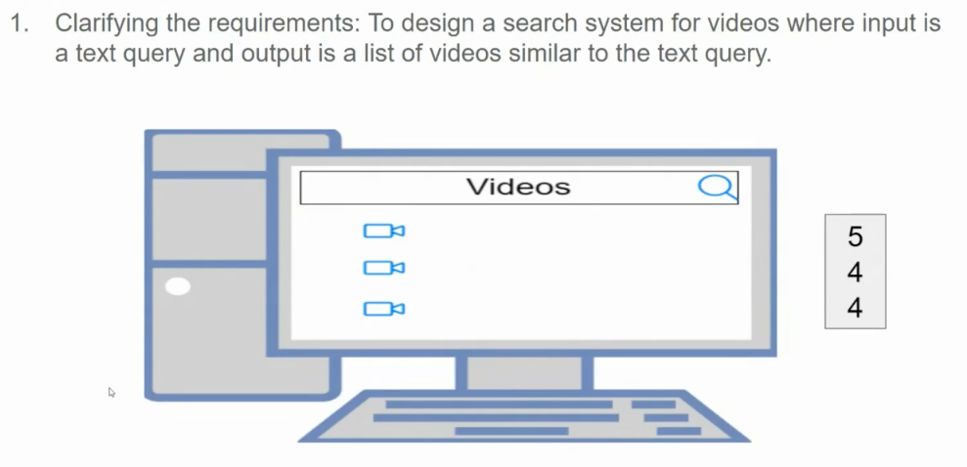

Framing as ML task

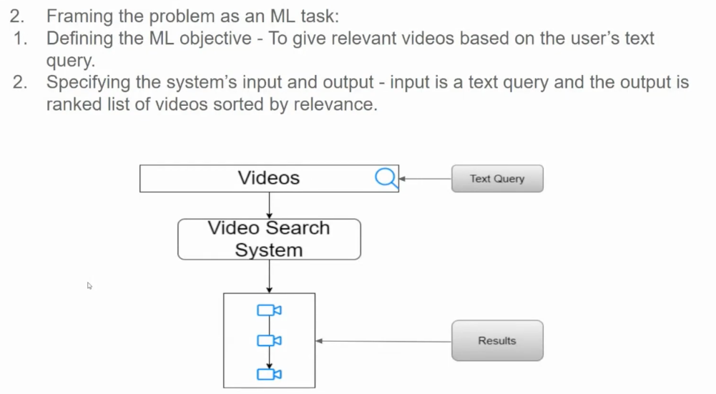

ML Objective: retrieve videos that are relevant to a text query

ML I/O: I: text query from a user, O: ranked list of relevant videos on a video sharing platform

ML category: Visual search + Text Search systems

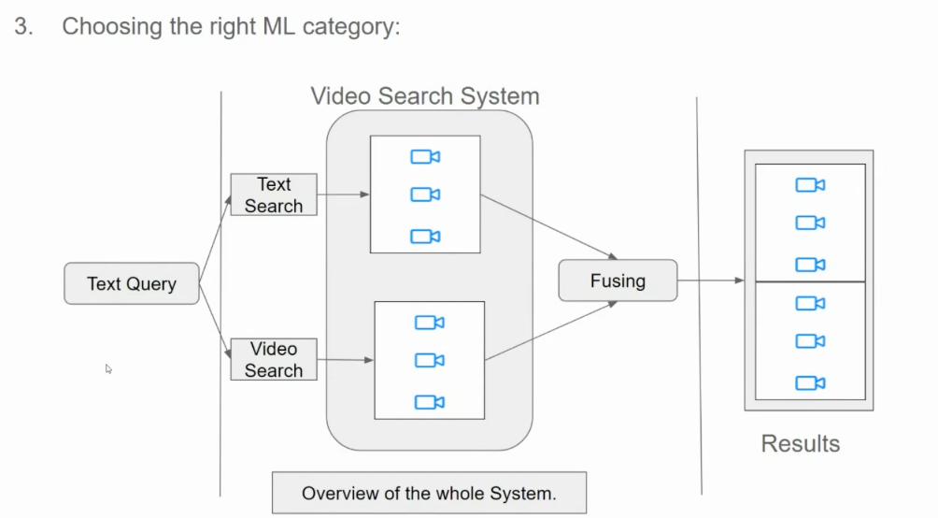

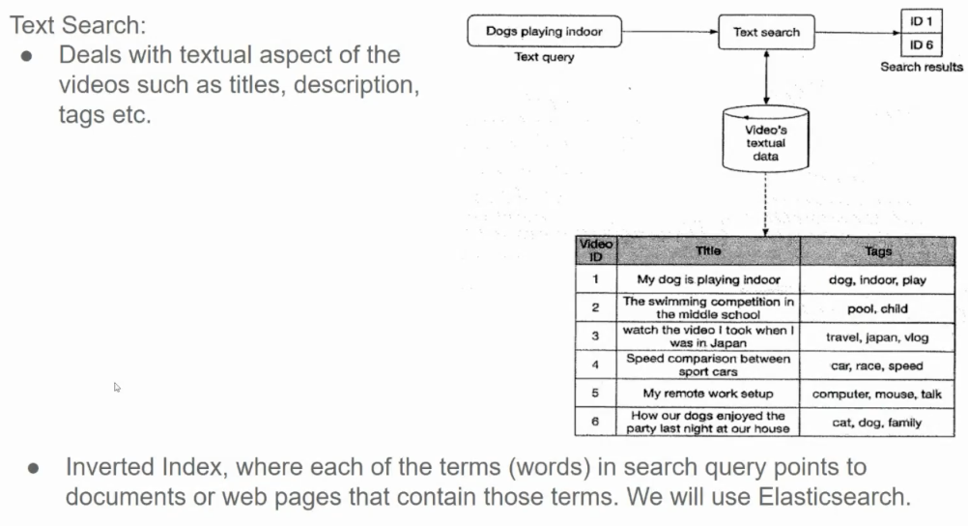

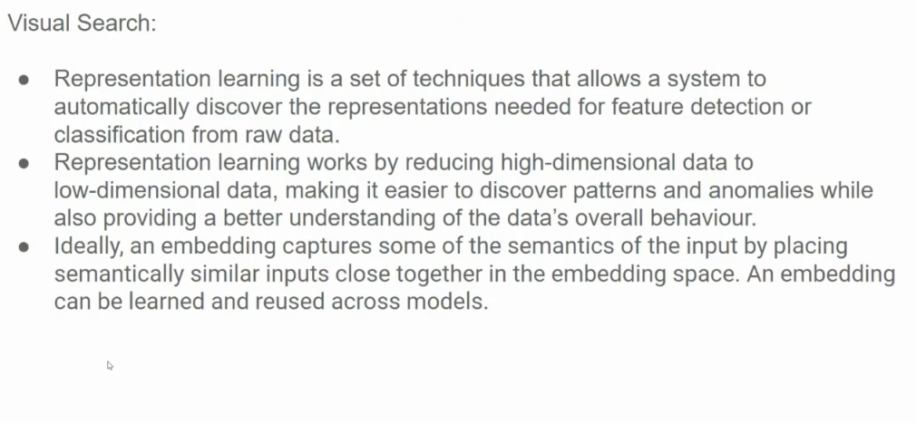

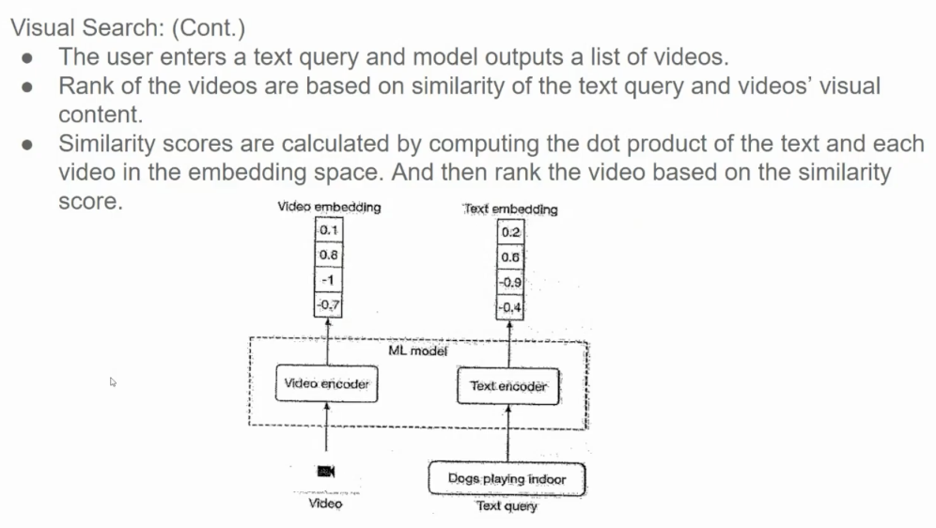

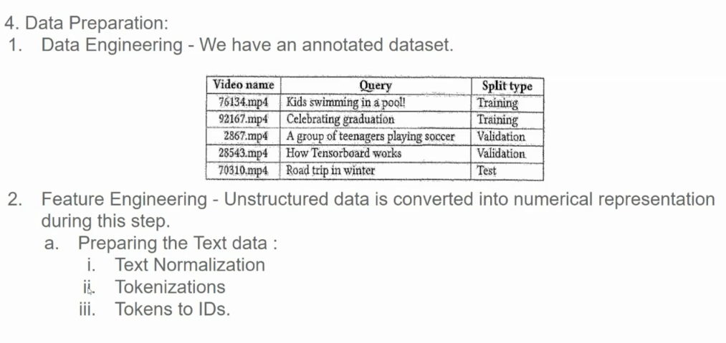

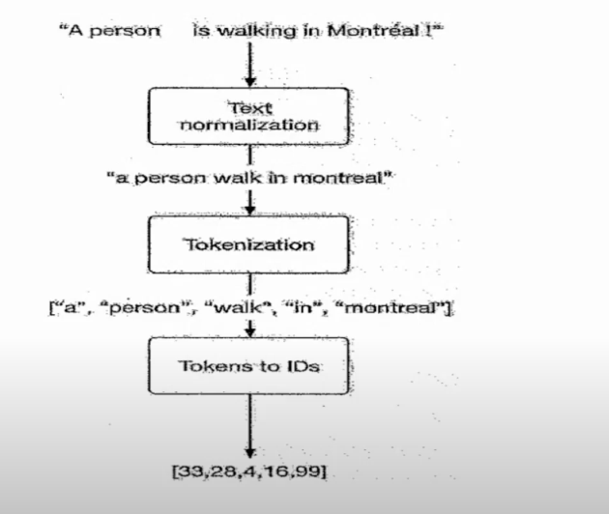

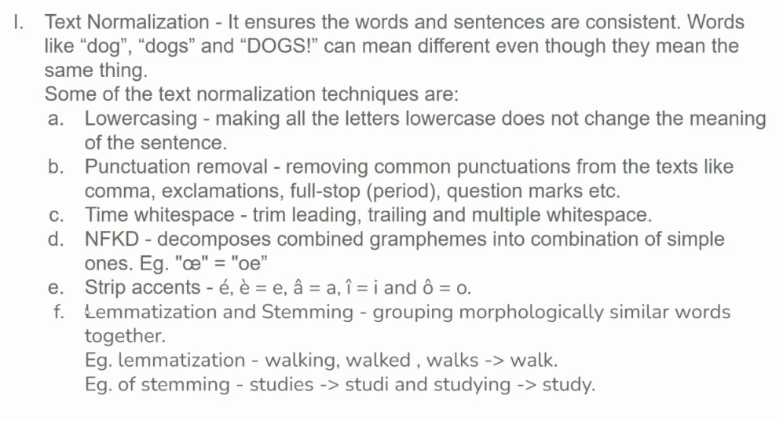

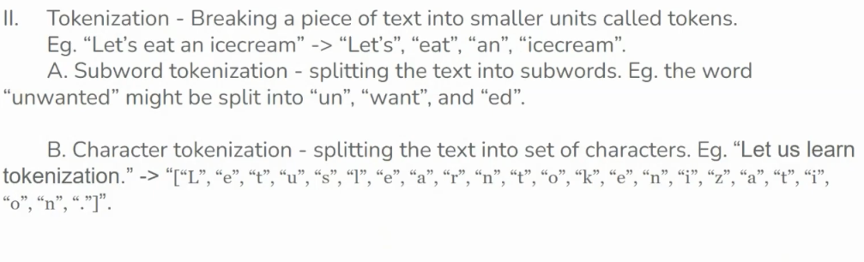

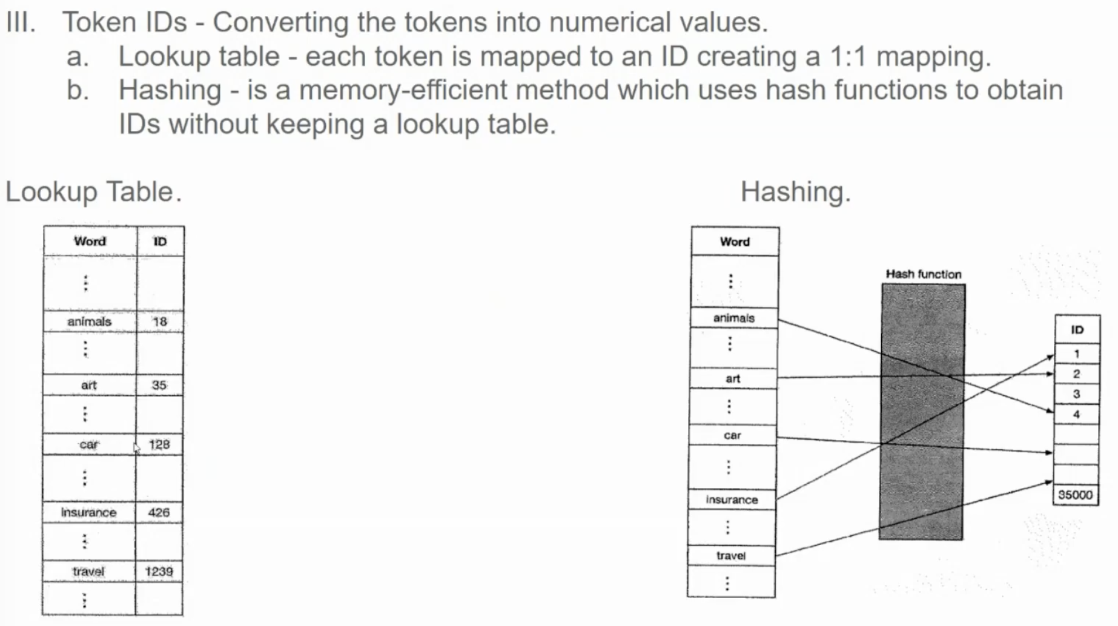

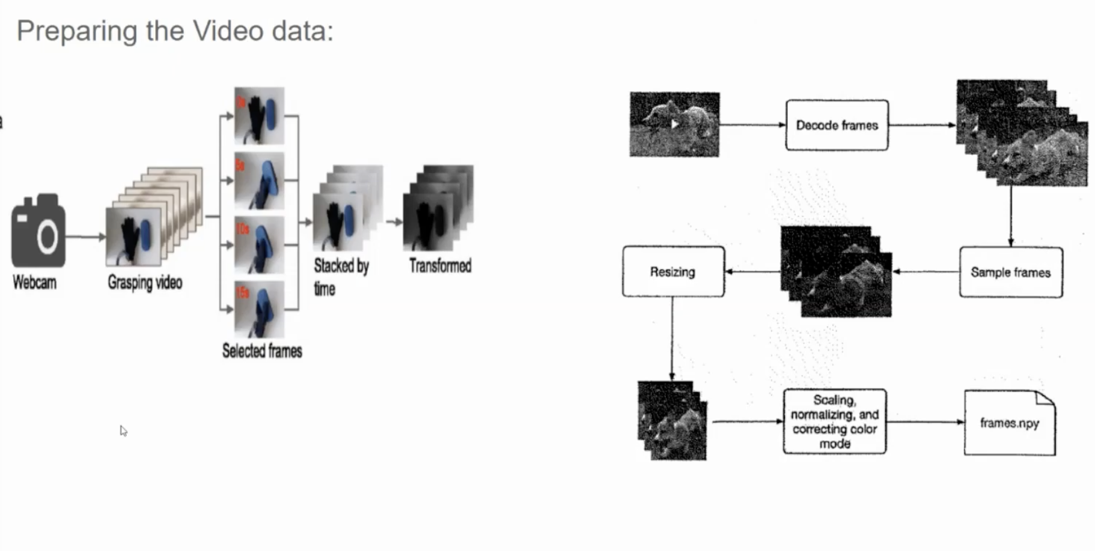

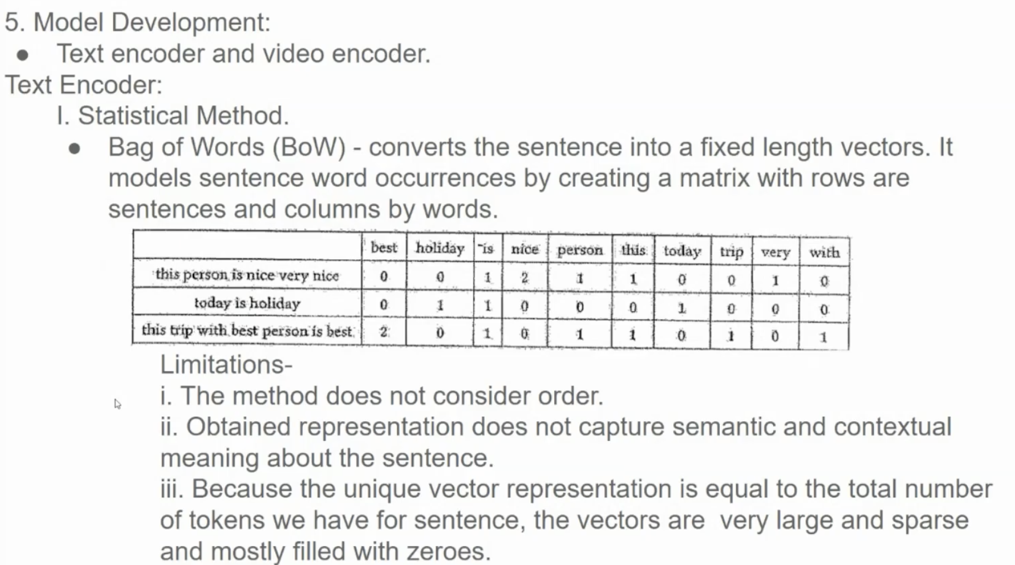

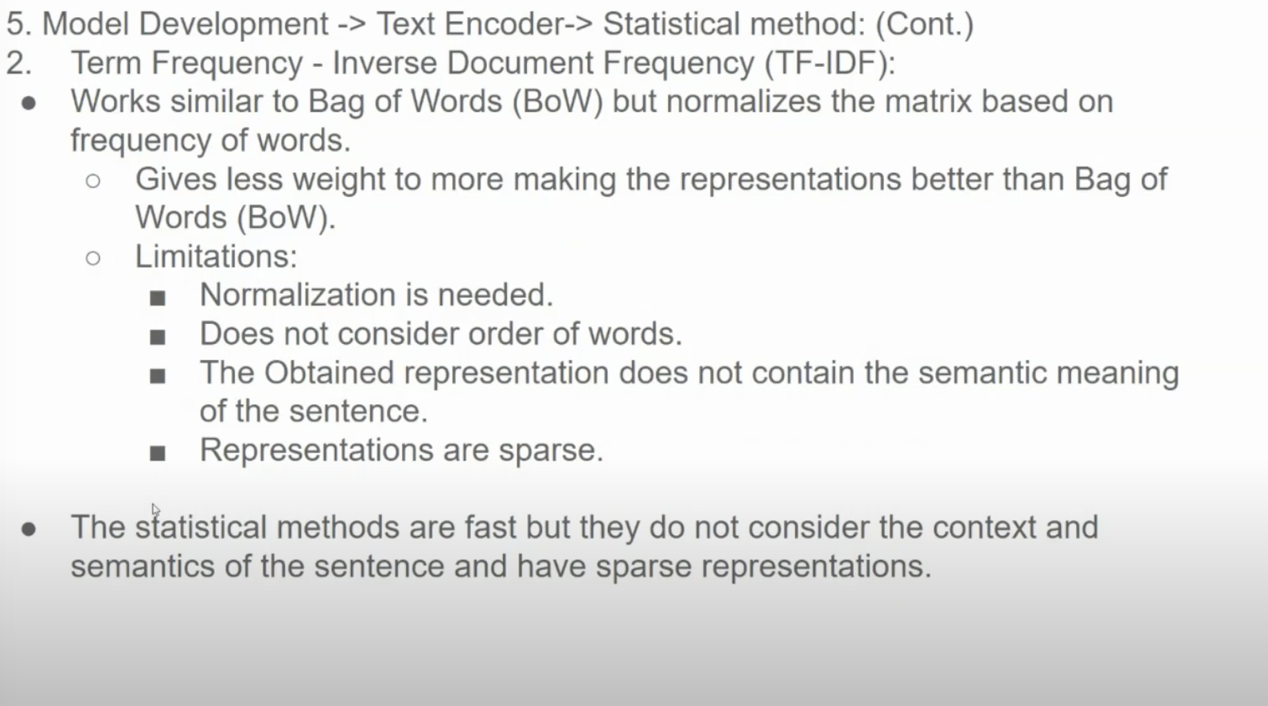

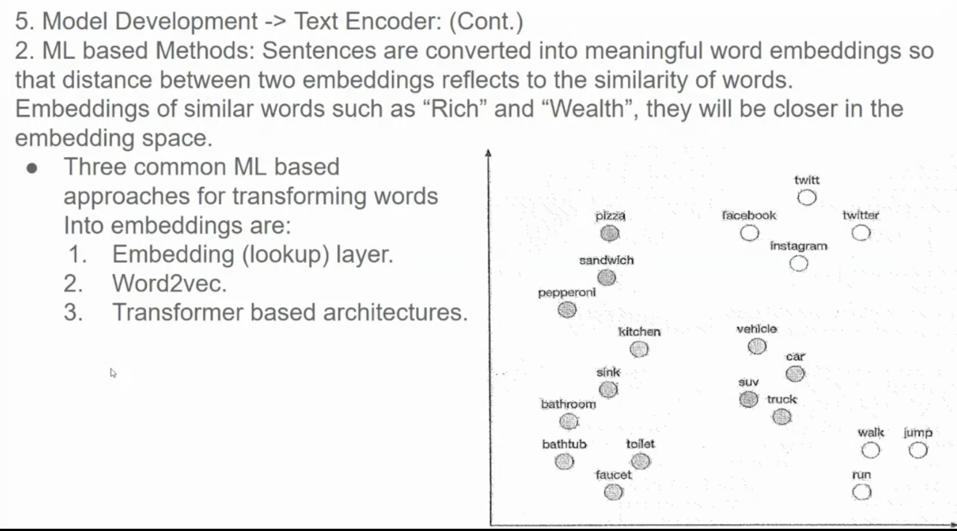

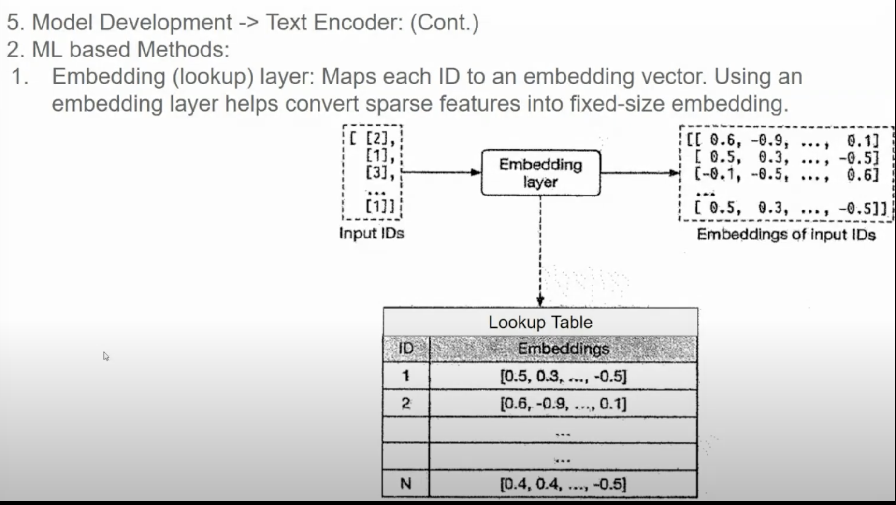

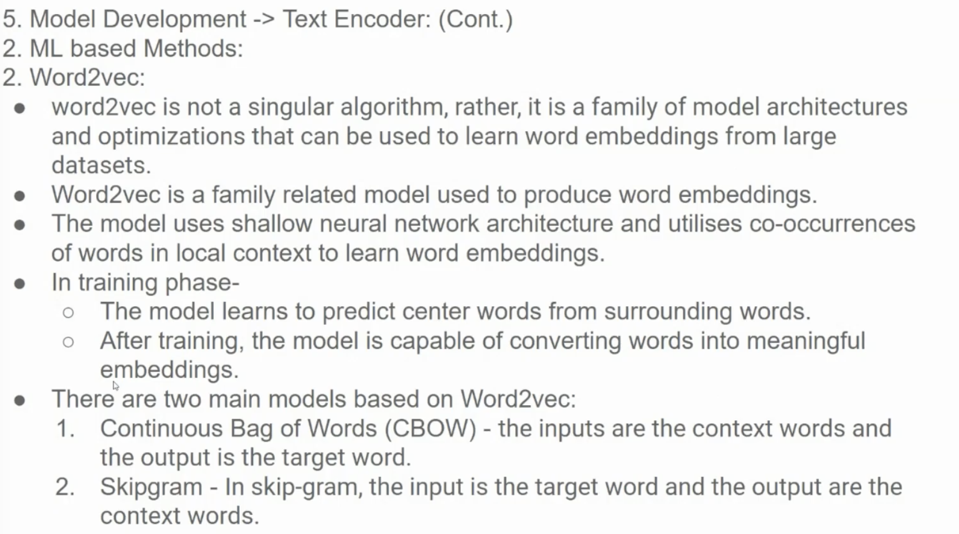

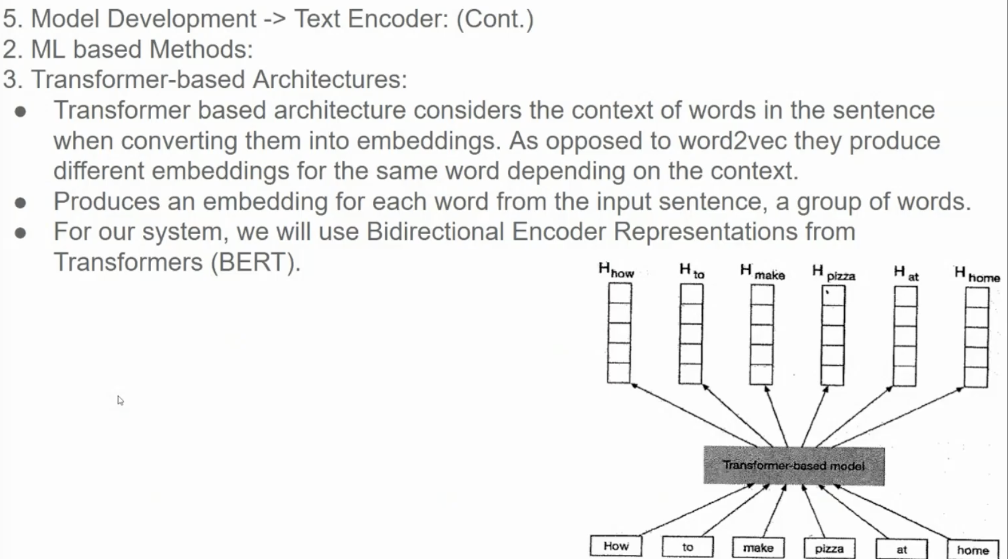

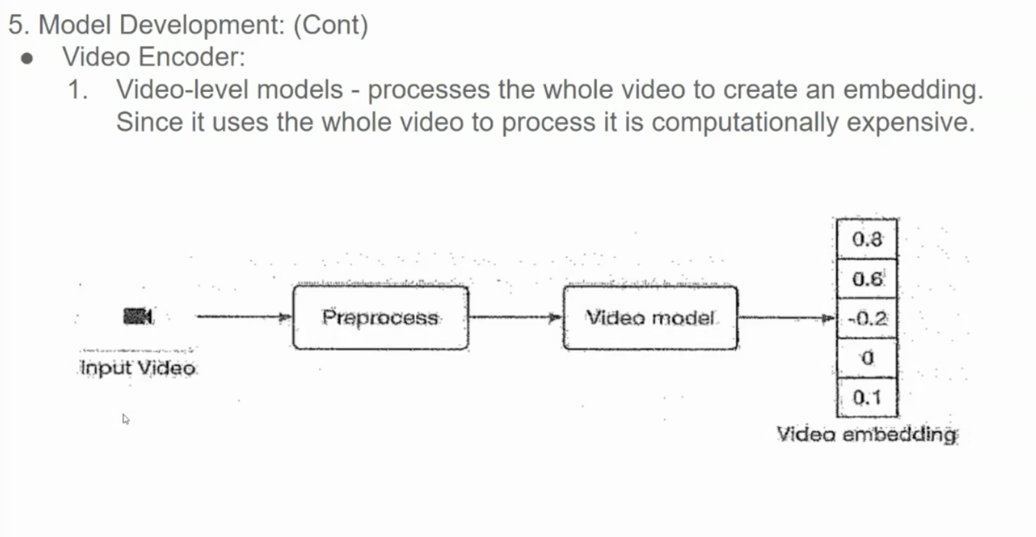

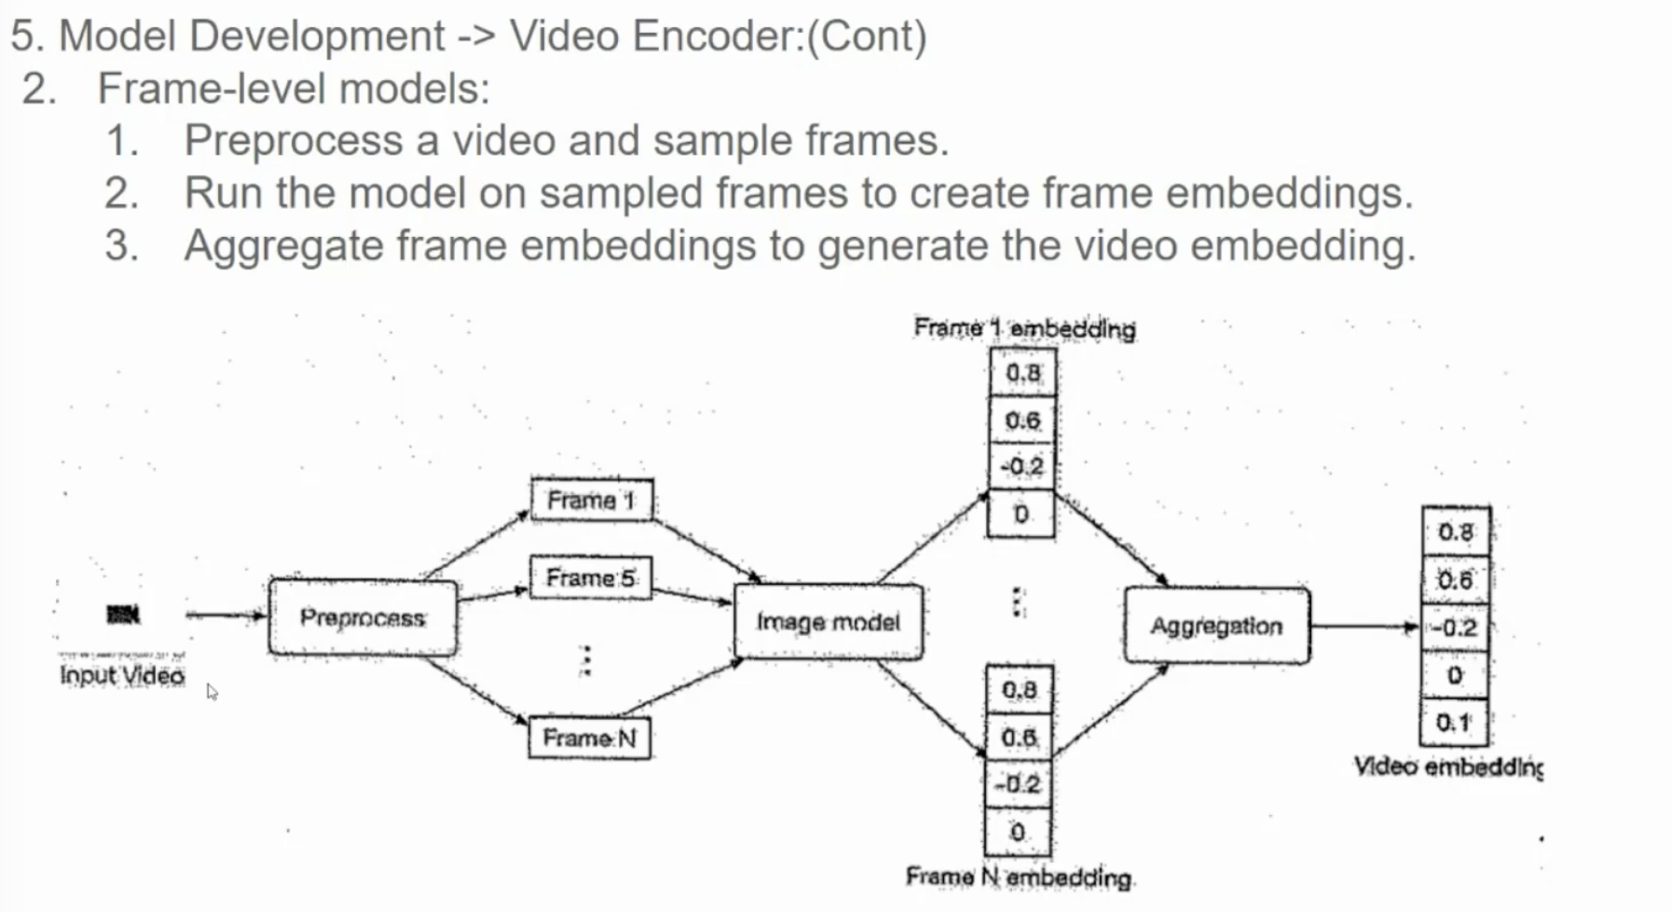

**1. Preprocessing:**

* **Video Input:** The input is a video clip.
* **Frame Sampling:** Key frames are extracted from the video. These frames can be sampled uniformly or based on motion or scene changes.

**2. Frame-Level Model:**

* **Image Model:** Each sampled frame is processed by an image model (e.g., a Convolutional Neural Network) to extract visual features.
* **Frame Embedding:** The image model generates a dense vector representation (embedding) for each frame. This embedding captures the semantic and visual information of the frame.

**3. Aggregation:**

* **Frame Embeddings:** The embeddings of all the sampled frames are combined to form a video-level representation.
* **Aggregation Techniques:** Various techniques can be used to aggregate frame embeddings, such as:
  + **Average Pooling:** Calculating the average of all frame embeddings.
  + **Max Pooling:** Selecting the maximum value from each dimension of all frame embeddings.
  + **Attention-Based Pooling:** Weighting frame embeddings based on their importance to the overall video content.

**Output:**

* **Video Embedding:** The final video embedding is a dense vector representation that captures the overall semantic and visual content of the video.

**Why Frame-Level Models?**

* **Fine-Grained Information:** Frame-level models can capture detailed information about the video content, such as object motion, scene changes, and temporal relationships between frames.
* **Flexibility:** They can be adapted to various video analysis tasks, including action recognition, video classification, and video retrieval.
* **Transfer Learning:** Pre-trained image models can be used as a starting point, saving time and computational resources.

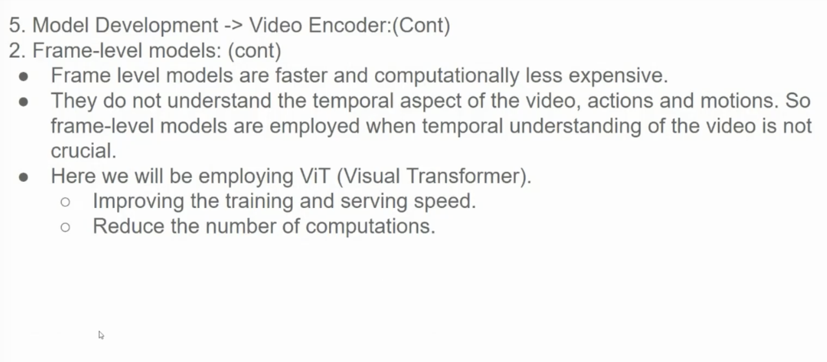

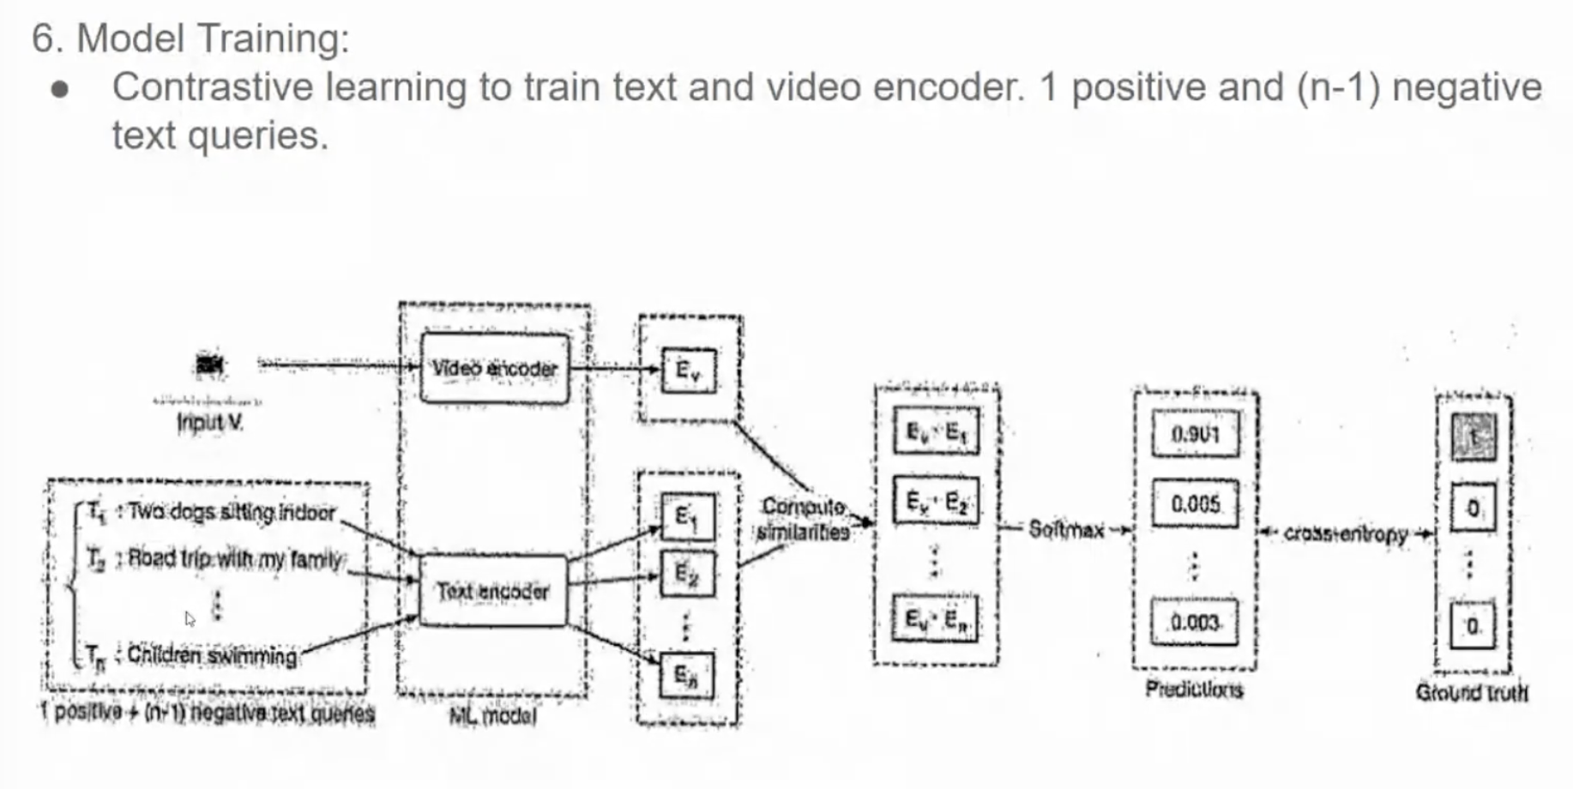

• **Input:** A video clip (V) and a set of text queries (T1, T2, T3,...). One of these queries (T1) is the positive query, and the others are negative queries.

• **Encoding:**

* The video clip (V) is passed through a video encoder to obtain a video embedding (Ev).
* Each text query (Ti) is passed through a text encoder to obtain a text embedding (Et).

• **Similarity Calculation:**

* The similarity between the video embedding (Ev) and each text embedding (Et) is calculated using a similarity function (e.g., cosine similarity).

• **Contrastive Loss:**

* A contrastive loss function is used to train the model. The goal is to maximize the similarity between the video embedding and the positive text query embedding, while minimizing the similarity between the video embedding and the negative text query embeddings.
* This loss function encourages the model to learn representations that capture the semantic and visual relationships between videos and text queries.

• **Model Training:**

* The model is trained iteratively on a large dataset of videos and text queries to minimize the contrastive loss.

• **Video Search:**

* At inference time, a user provides a text query.
* The text query is passed through the text encoder to obtain a query embedding.
* The query embedding is then compared to the embeddings of all videos in the database using the similarity function.
* The videos with the highest similarity scores are returned as search results.

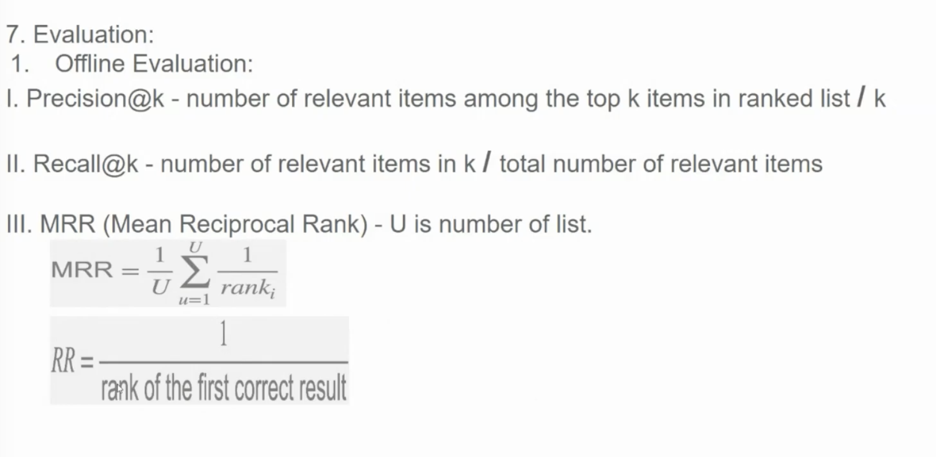

**Understanding Offline Evaluation Metrics for Recommendation Systems**

The provided image outlines several key offline metrics used to evaluate the performance of recommendation systems. Let's break down each metric:

**1. Precision@k and Recall@k**

* **Precision@k:** Measures the proportion of relevant items among the top k items in a ranked list.
  + **Formula:** Precision@k = Number of relevant items in top k / k
* **Recall@k:** Measures the proportion of relevant items that are retrieved among the top k items.
  + **Formula:** Recall@k = Number of relevant items in top k / Total number of relevant items

**Example:**

Consider a search engine that returns 10 results for a query. If 5 of the top 10 results are relevant, then:

* Precision@10 = 5/10 = 0.5
* Recall@10 depends on the total number of relevant items in the entire dataset. If there are 20 relevant items in total, and 5 of them are in the top 10, then Recall@10 = 5/20 = 0.25

**2. Mean Reciprocal Rank (MRR)**

* Measures the average reciprocal rank of the first relevant item in a ranked list.
* A higher MRR indicates that relevant items are ranked higher.

**Formula:**

MRR = (1/rank_1 + 1/rank_2 + ... + 1/rank_u) / U

Where:

* U is the number of user queries.
* rank_i is the rank of the first relevant item for the i-th query.

**Example:**

If for the first query, the relevant item is ranked 3rd, for the second query, it's ranked 1st, and for the third query, it's ranked 2nd, then:

* MRR = (1/3 + 1/1 + 1/2) / 3 = 11/18

**3. Reciprocal Rank (RR)**

* A simpler metric that measures the reciprocal rank of the first relevant item in a single ranked list.

**Formula:**

RR = 1 / rank

Where rank is the rank of the first relevant item.

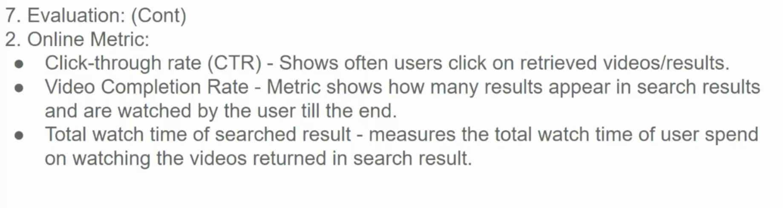

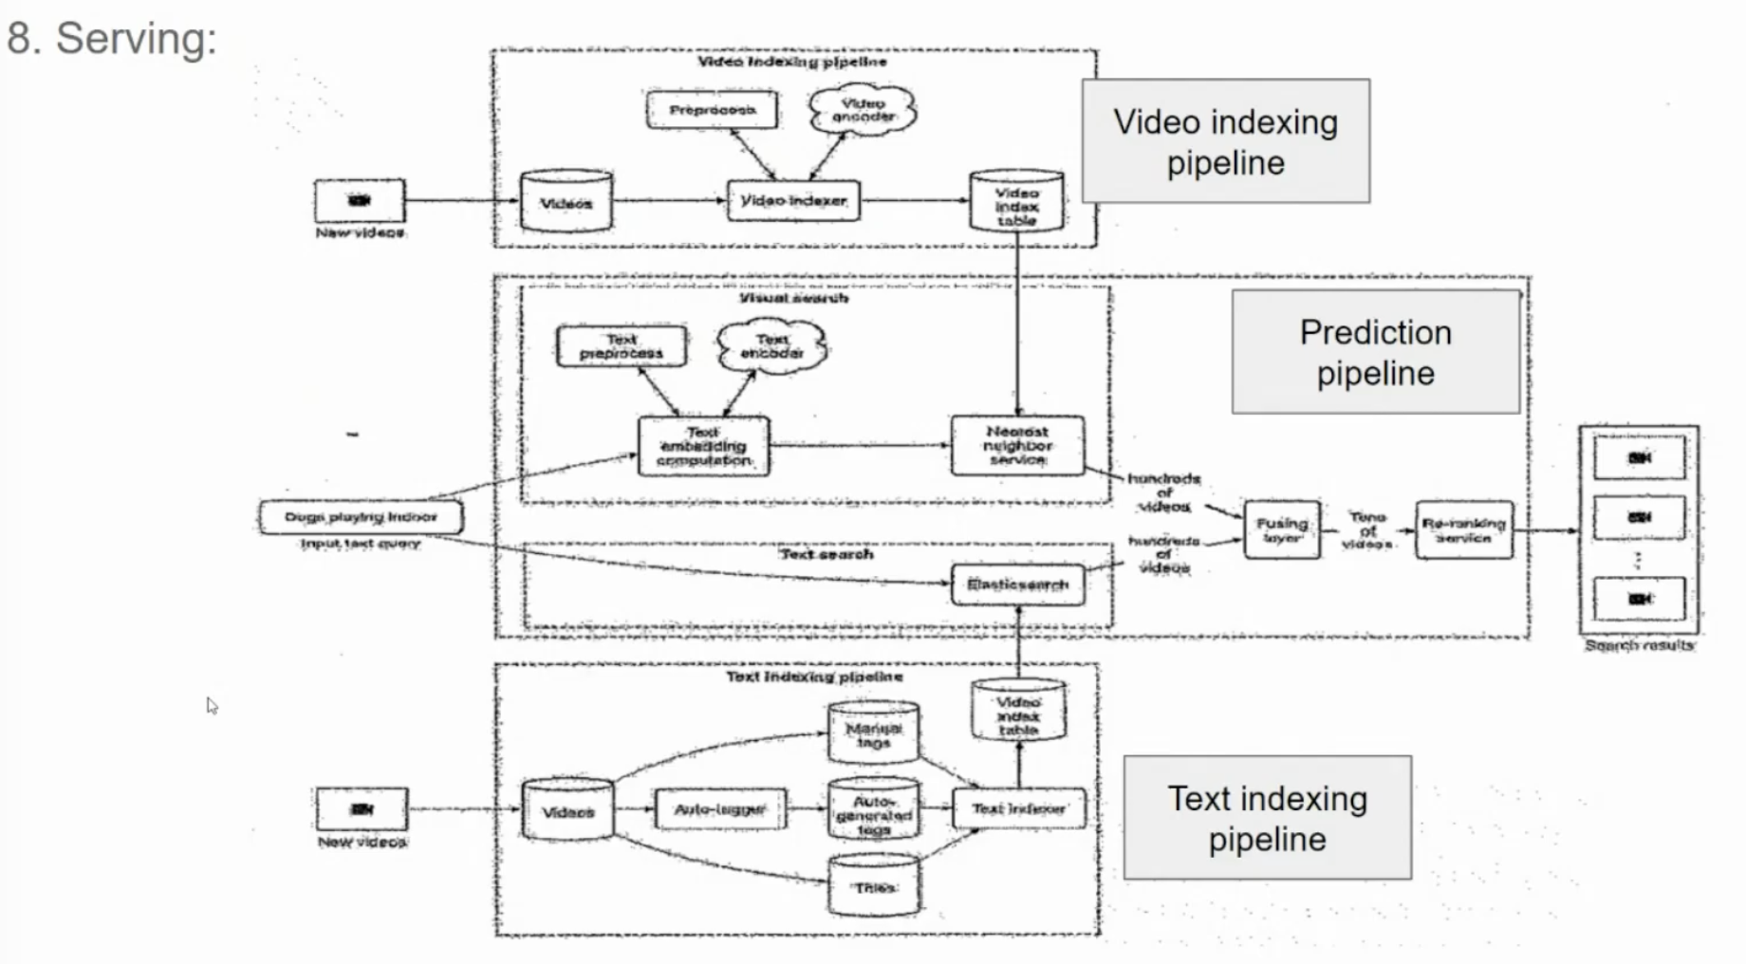

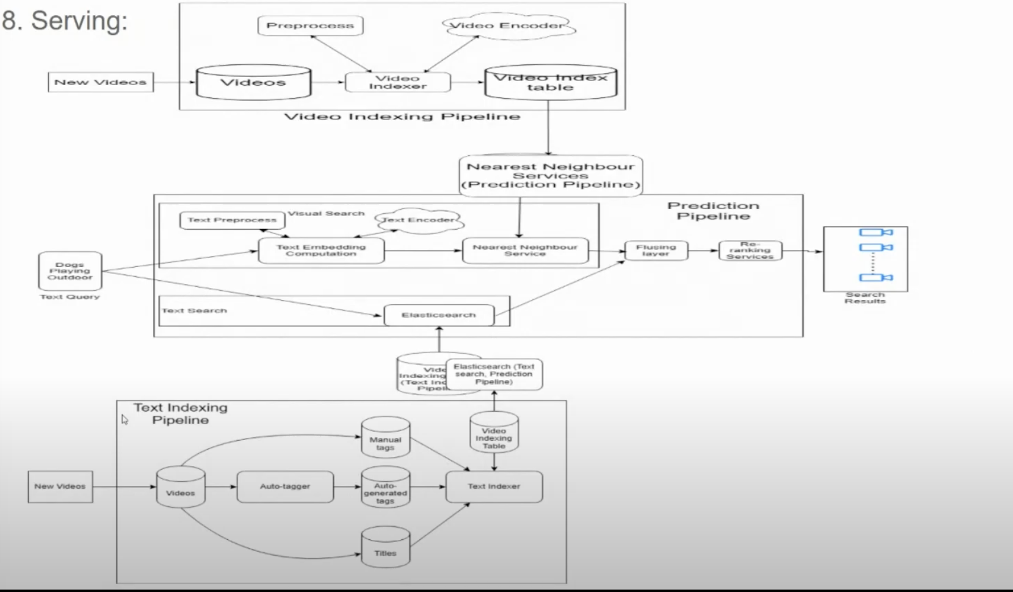

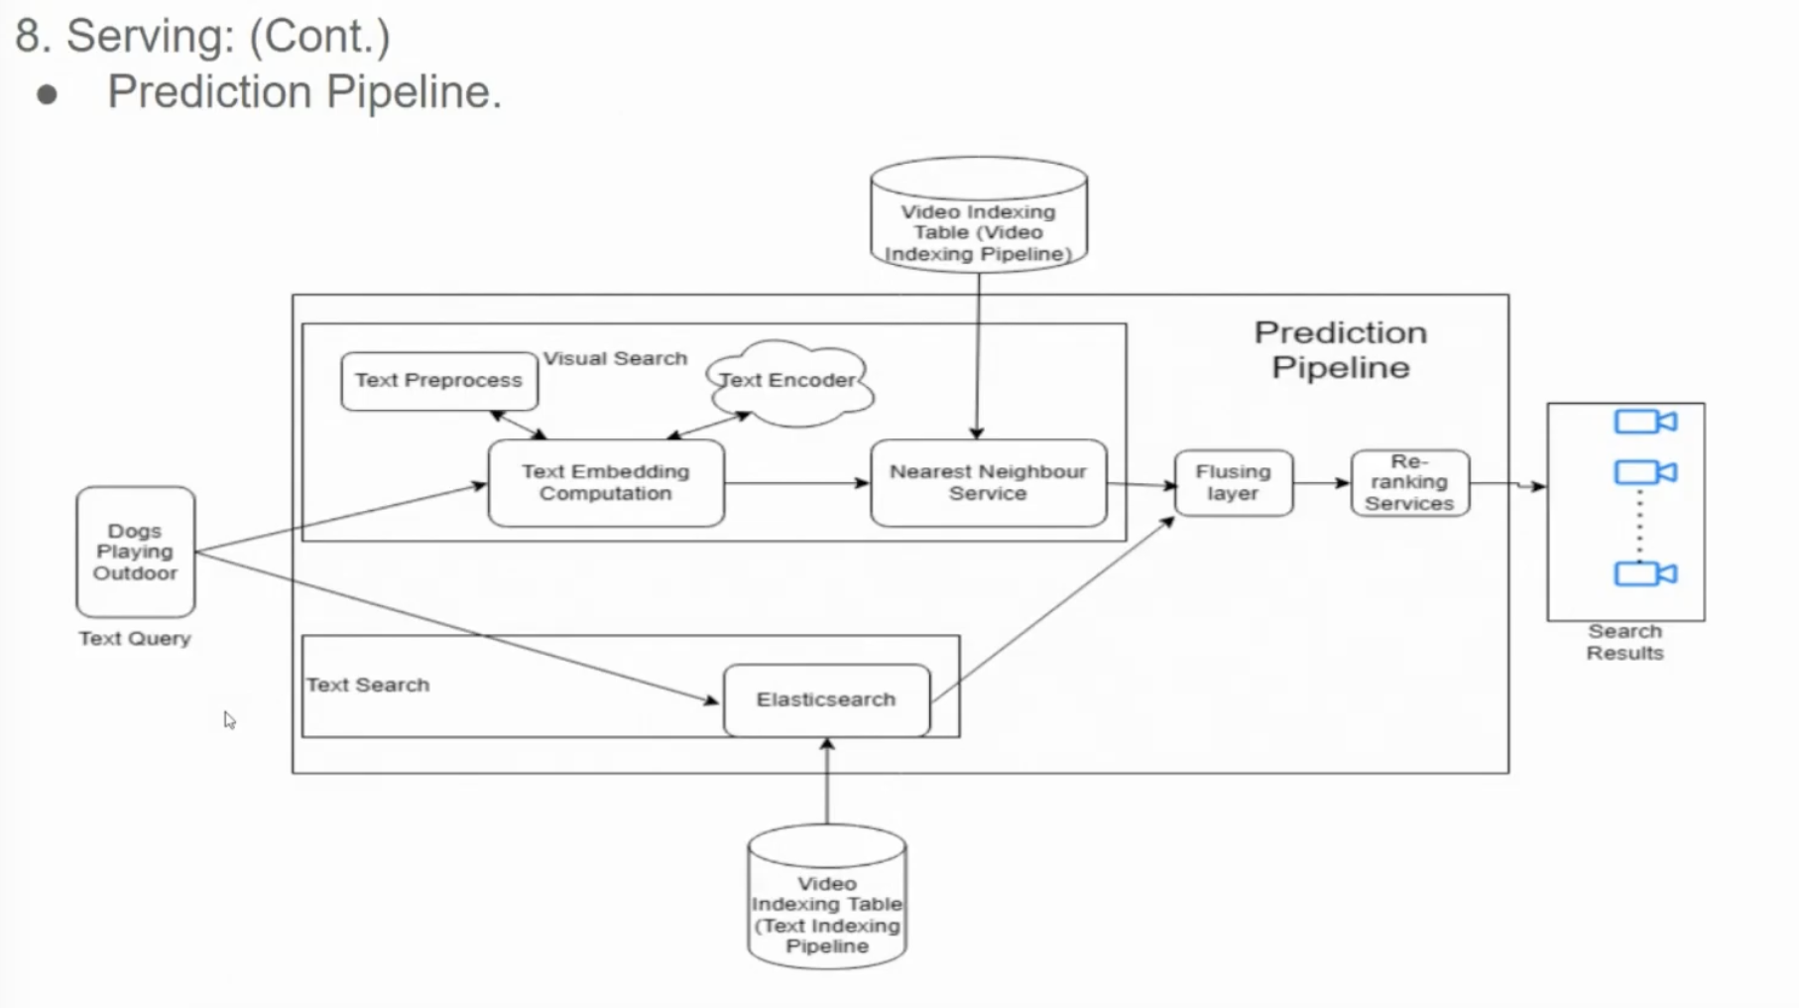

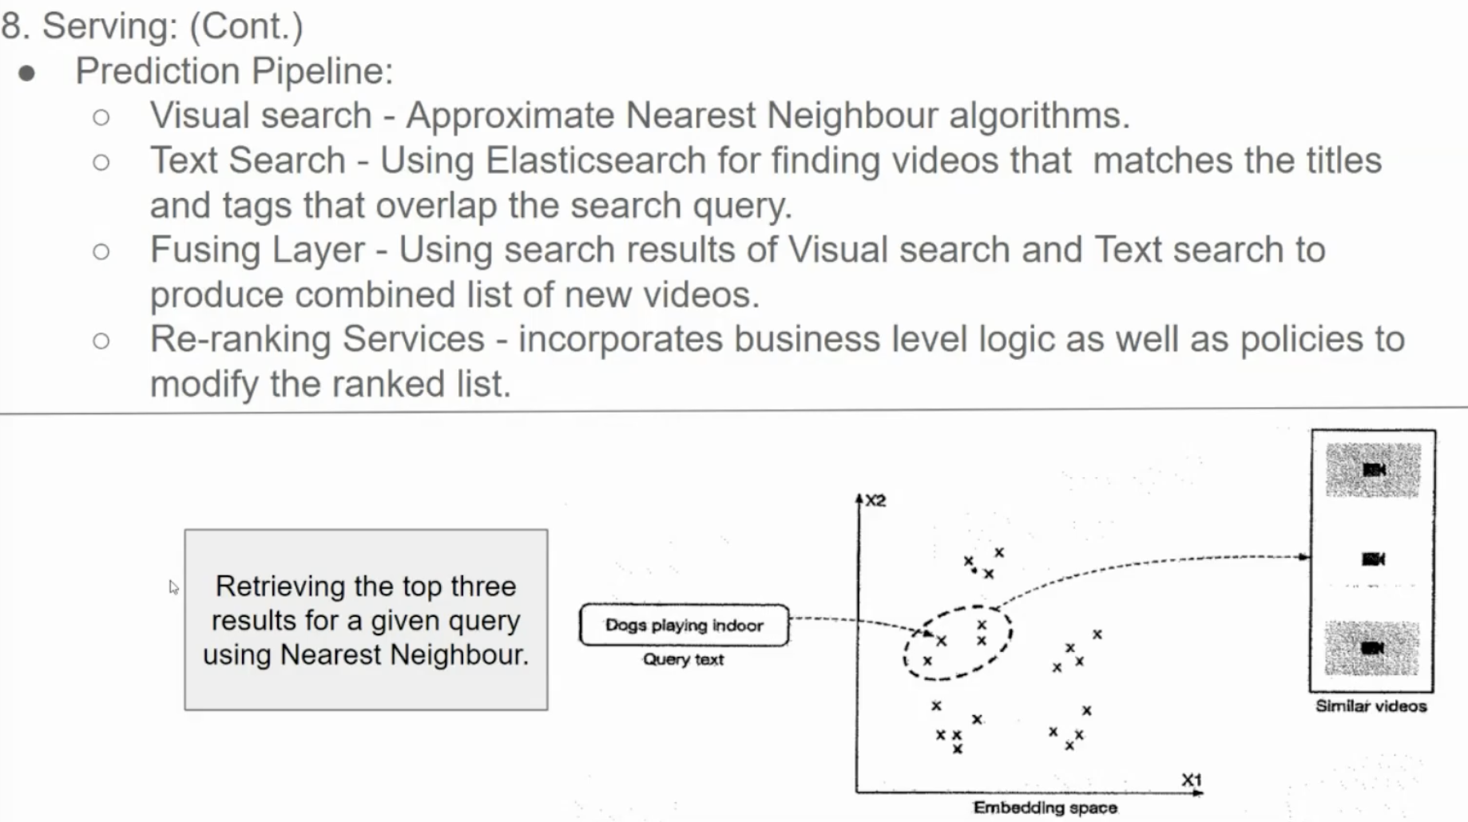

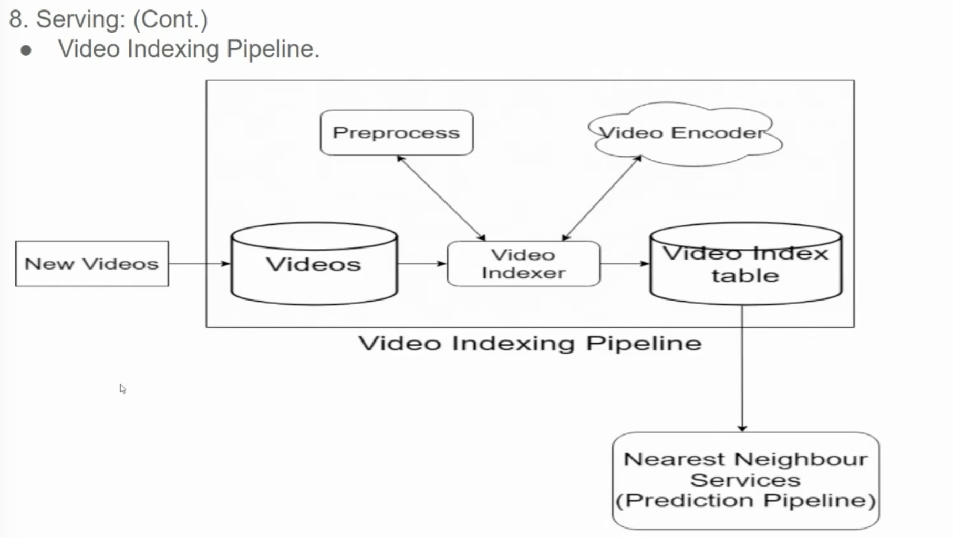

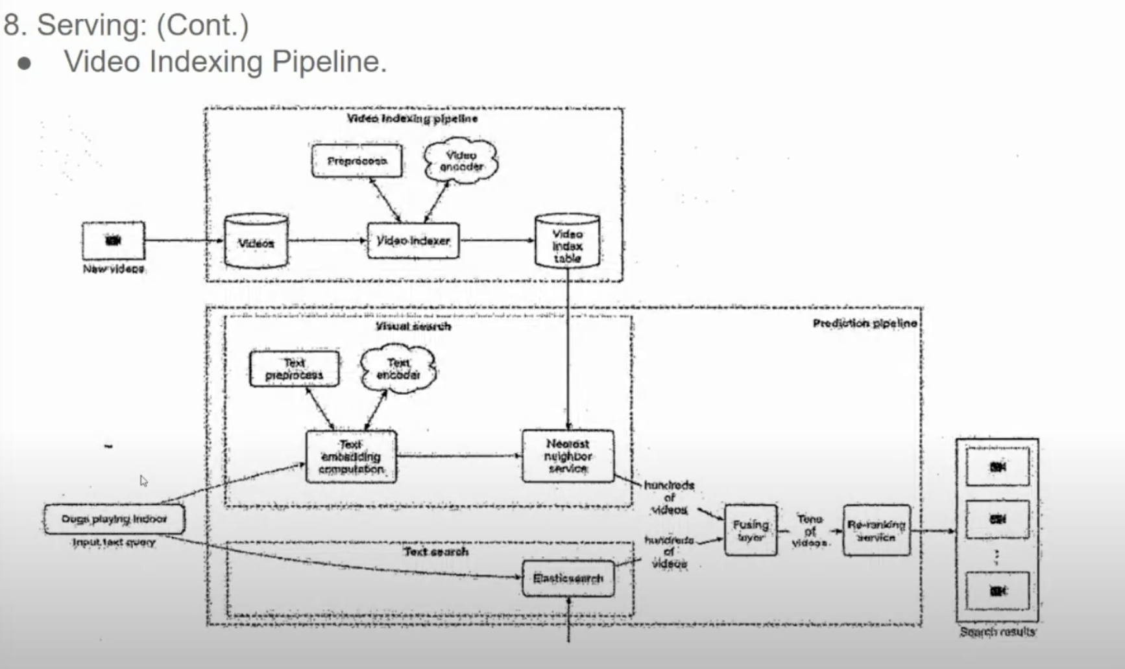

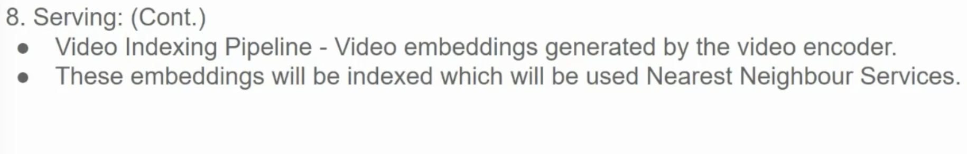

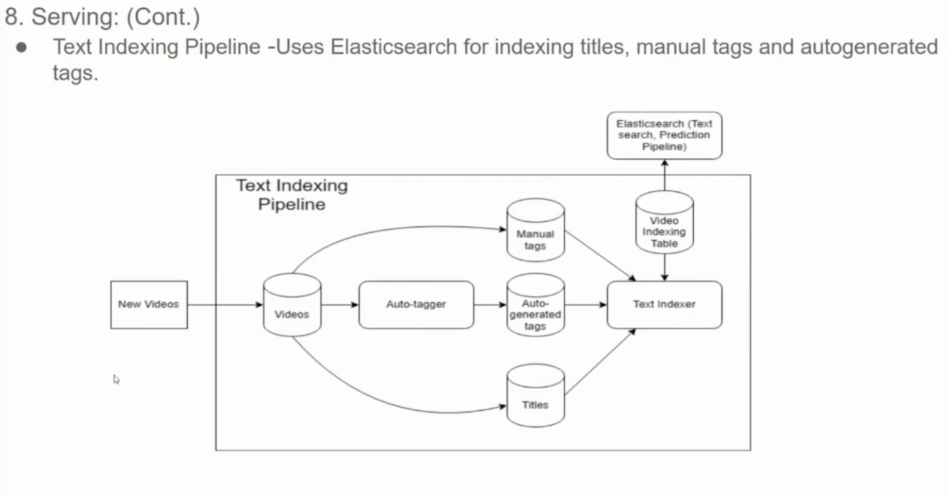

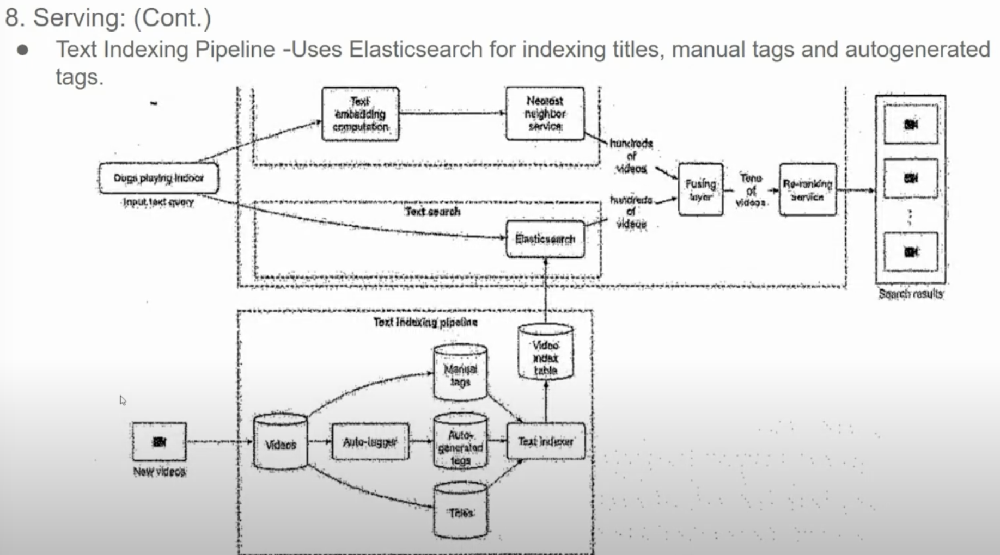

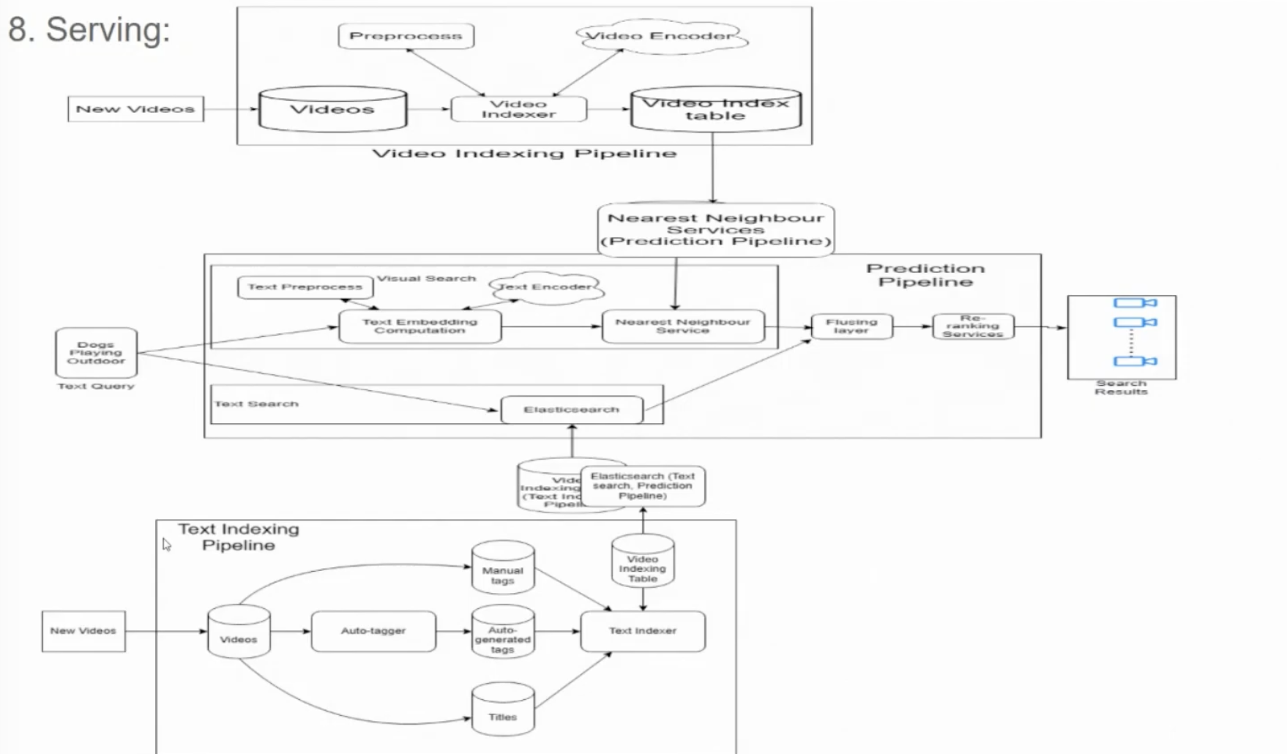

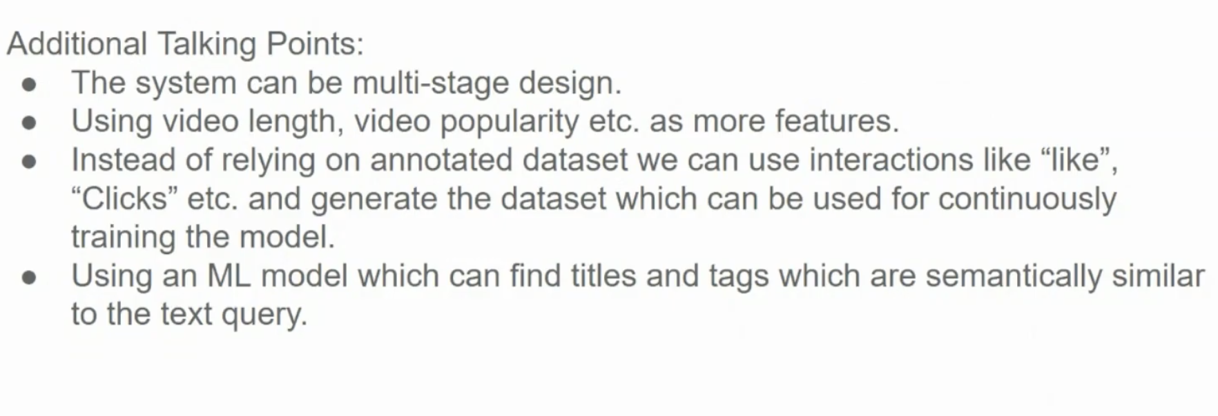

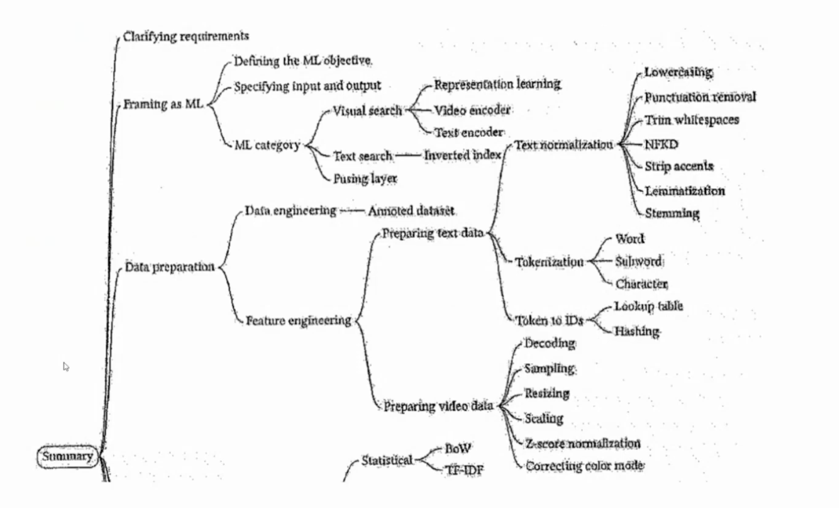

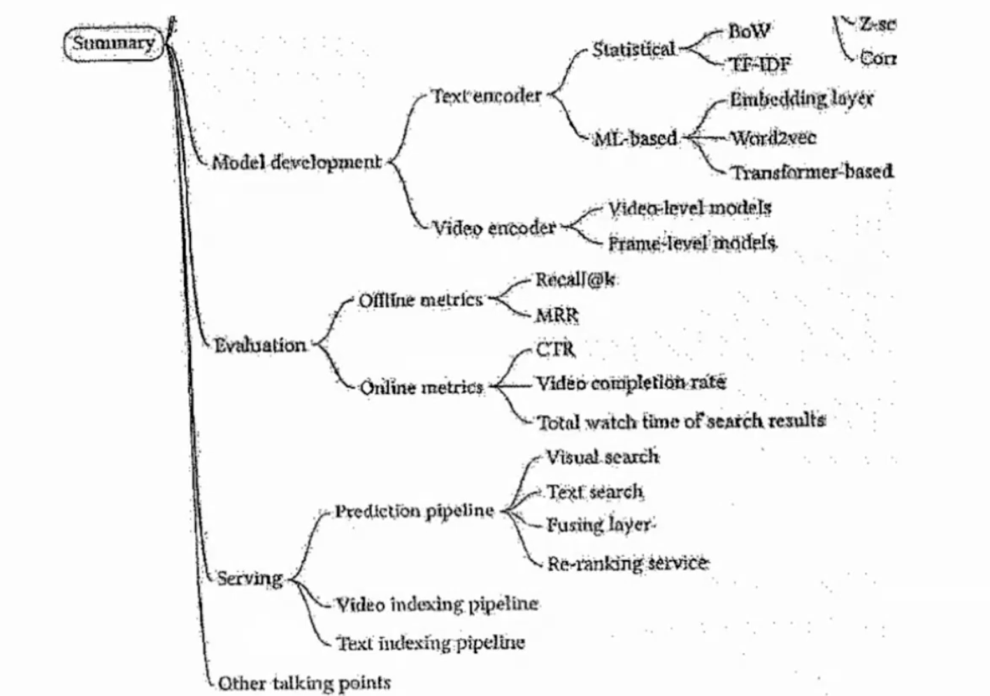  
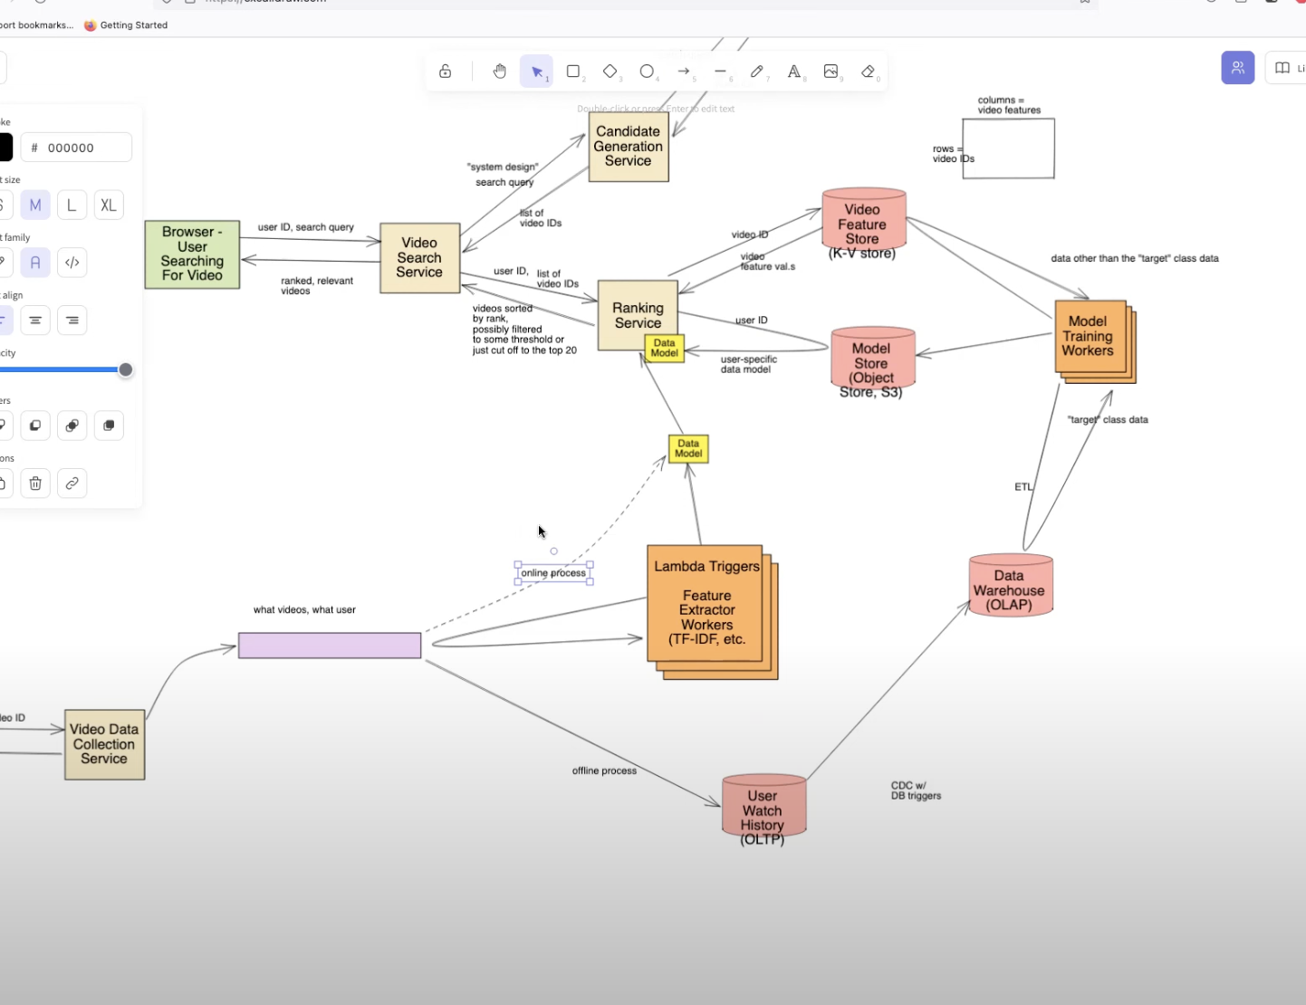

https://www.youtube.com/watch?v=nprPYgn4E58&list=PLlvnxKilk3aKx0oFua-HTtFf-d_inQ8Qn&index=3